# Kanban – Sales Opportunities

The prebuilt *Kanban – Sales Opportunities* provides an overview of registered opportunities in your NetSuite account, with each Kanban column representing an opportunity status. The last column contains two Kanban columns, stacked on top of each other, one representing opportunities won this month and the other one opportunities lost this month.

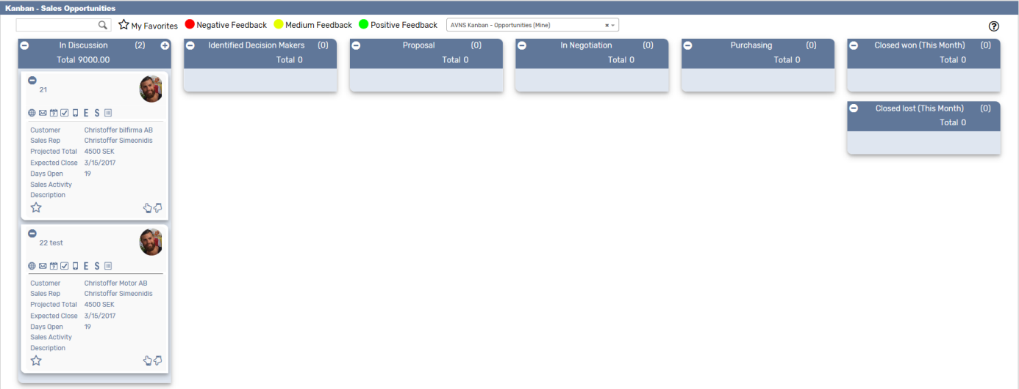

### Kanban – Sales Opportunities: Prerequisites

Before using the *Kanban – Sales opportunities* board, please make sure the prerequisites listed below are fulfilled in order for the board to function as expected.

1. **Customer Status**  
   Since the columns of the prebuilt *Kanban – Sales Opportunities* board are based on NetSuite standard Customer status, it is important that the statuses presented in the board are available in your NetSuite account.   
     
   Navigate to Setup 🡪 Sales 🡪 Customer Statuses (Administrator) to find the list of Customer Statuses available in your NetSuite account. Compare the list from your NetSuite account with the Customer Status list which the prebuilt *Kanban – Sales Opportunities* board is based on (picture below).   
     
   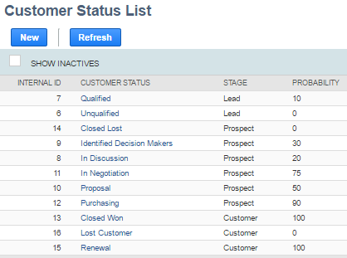  
     
   If the Customer Statuses differ between your NetSuite account and the picture above, you will need to edit the settings of the Kanban Columns for the *Kanban – Sales Opportunity* board.  
   ***Please refer to the section ‘Kanban Columns’ in the ‘Kanban User Guide’***
2. **Sales Rep & Sales Rep Image**  
   Make sure to mark the checkbox ‘Sales Rep’ on the Employee record for all available Sales Reps.   
   If an image has been uploaded to the *Image* field on the Employee record, this image will be displayed on the Kanban card. If no image is available, a predefined profile icon will be displayed instead.

### 

### Kanban – Sales Opportunities: Card Moves & Column Actions

The *Kanban – Sales opportunities* board contains six Kanban Columns. Each column has been configured with one or several Column Actions. Double clicking on any card in the *Kanban – Sales Opportunities* board will open the opportunity record in edit mode.

1. **In Discussion**
   1. *Card Moves* – Kanban cards in the column *In Discussion* can be moved to Identified decision Makers and *Closed lost (This Month)*.
   2. *Column Actions* – when moving a Kanban card to the column *In Discussion* the status of the record represented in the Kanban card will be updated to *In Discussion.*
   3. *Add Card* – it is possible to add a Kanban card (a new record) from the column *In Discussion* by clicking on the + icon in the top right corner of the column.
2. **Identified Decision Makers**
   1. *Card Moves* – Kanban cards in the column *Identified Decision Makers* can be moved to In discussion and Closed lost (This Month).
   2. *Column Actions* – when moving a Kanban card to the column *Identified Decision Maker* the status of the record represented in the Kanban card will be updated to *Identified Decision Makers*.
3. **Proposal**
   1. *Card Moves* – Kanban cards in the column *Proposal* can be moved to In Negotiation and Purchasing.
   2. *Column Actions* – when moving a Kanban card to the column *Proposal* the status of the record represented in the Kanban card will be updated to *Proposal.* This is not possible from lower levels but to move a card here you need to create an estimate. Netsuite will automatically set status to *Proposal* on your opportunity. You can also manually do this to force card movement.
4. **In Negotiation**
   1. *Card Moves* – Kanban cards in the column *In Negotiation* can be move to proposal or purchasing.
   2. *Column Actions* – when moving a Kanban card to the column *In Negotiation* the status of the record represented in the Kanban card will be updated to *In Negotiation*.
5. **Purchasing**
   1. *Card Moves* – Kanban cards in the column *Purchasing* can be moved to proposal or in negotiation.
   2. *Column Actions* – when moving a Kanban card to the column *Purchasing* the status of the record represented in the Kanban card will be updated to *Purchasing*.
6. **Closed Won**
   1. *Card Moves* – Kanban cards in the column *Closed Won (This Month)* can´t be moved. In order move cards here you need to create a Sales order.
   2. *Column Actions* – when moving a Kanban card to the column *Closed Won (This Month)* the status of the record represented in the Kanban card will be updated to *Closed Won*.
7. **Closed Lost**
   1. *Card Moves* – Kanban cards in the column *Closed lost (This Month)* can be moved to all other columns in the Kanban board.
   2. *Column Actions* – when moving a Kanban card to the column *Closed lost (This Month)* the status of the record represented in the Kanban card will be updated to *Closed* Lost*.*

### Kanban – Sales Opportunities: Available Card Actions

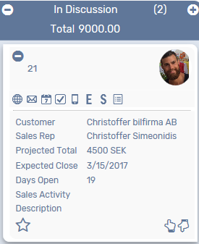The Kanban cards in the *Kanban – Sales Opportunities* board each contains eight Card Actions.

1. **View Customer 360**

Run the customer 360 report.

1. **New Email**Add a new email.
2. **New Event**

Add a new event.

1. **New Task**Add a new task.
2. **New Phone Call**Add a new phone call.
3. **New Estimate**Create an estimate from your opportunity.
4. **New Sales Order**Create a sales order from your opportunity.
5. **Show Activity**Show a list of all activities.

### Kanban – Sales Opportunities: Alternative Searches

There are three alternative searches for the *Kanban – Sales opportunities* board.

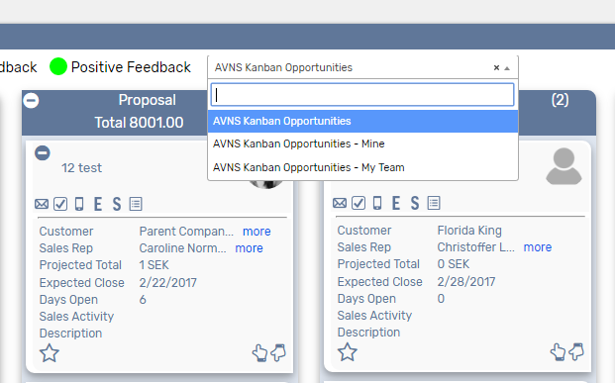

1. **AVNS Kanban Opportunities**

This search will display all registered opportunities.

1. **AVNS Kanban Opportunities - Mine**This search will display opportunities registered to me.
2. **AVNS Kanban Opportunities – My Team**This search will display opportunities registered to a member of my team.

### Kanban – Sales Opportunities: Available Colors

There are three colors available for the *Kanban – Sales Opportunities* board, which can be used to highlight and filter the Kanban cards (Negative / Medium / Positive feedback). These are defined in the *Color* subtab of the Kanban configuration record. 